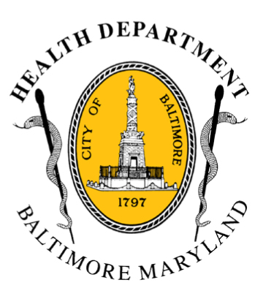
BCHD PRESS RELEASE
Baltimore City Health Department
1001 E. Fayette Street • Baltimore, Maryland 21202
Stephanie Rawlings-Blake, Mayor
Leana Wen, M.D., Commissioner of Health

FOR IMMEDIATE RELEASE
Media Contact: Michael Schwartzberg, PIO
O: (443) 984-2623 C: (443) 462-7939 E: michael.schwartzberg@baltimorecity.gov
Baltimore City Health Department Working To Ensure
Prescription Availability For Residents Impacted By Civil Unrest

BALTIMORE, MD (May 1, 2015) – The Baltimore City Health Department is leading efforts with the city’s 311 system to ensure prescription medicine is available to residents who are impacted by the current civil unrest. At least 10 retail pharmacies are closed, including two CVS locations that were burned, and eight Rite Aid locations that suffered fire and / or looting damage.

The Health Department, in coordination with the Mayor’s Office of Emergency Management, Maryland Department of Health & Mental Hygiene and area pharmacies, has developed the Baltimore Pharmacies Operations List, a list of pharmacies in the city that are closed. This list will be updated daily on the BCHD website, health.baltimorecity.gov, until normal operations resume. We will also continue to regularly update our Twitter (https://twitter.com/Bmore_Healthy) and Facebook (www.facebook.com/BaltimoreHealth) social media pages, using the hashtag #HealBaltimore.
Health Department staff will assist individuals with:
- Locating the nearest open pharmacy;
- Obtaining prescriptions through mail delivery, or
- Arranging for delivery of prescriptions to BCHD’s Druid Health Clinic
“Our residents need to get medical care they need, which includes life-sustaining medications,” said Baltimore City Health Commissioner Dr. Leana Wen. “We will do everything possible so that seniors and other vulnerable citizens receive their prescription medications.”

Individuals in affected areas who are having difficulty obtaining prescription medication should call 311. The Baltimore City Health Department will help to locate the nearest open pharmacy and have prescriptions transferred.

- more -

2-2-2

For those with transportation concerns or limited mobility, the Health Department will assist with alternate options that include obtaining prescriptions through mail delivery or arranging for delivery of prescriptions to the City’s Druid Health Clinic.

“We at the Health Department are working around the clock to protect vital resources and coordinate with pharmacies and our partners across the city,” said Dr. Wen. As the city recovers, we are dedicating all efforts to protect the health and well-being of our residents.”

###

